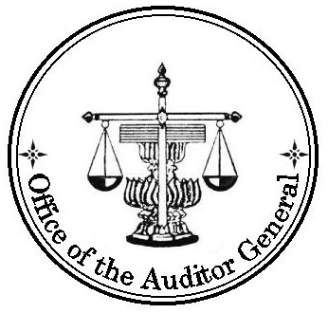
( TRANSLATION)

AUDITOR’S REVIEW REPORT

TO : THE SHAREHOLDERS OF PTT PUBLIC COMPANY LIMITED

The Office of the Auditor General of Thailand has reviewed the accompanying consolidated balance sheet of PTT Public Company Limited and its subsidiaries and the balance sheet of PTT Public Company Limited as at June 30, 2005, and the related consolidated and the Company’s statements of income for the three-month and six-month periods ended June 30, 2005 and 2004, changes in shareholders’ equity, and cash flows for the six-month periods ended June 30, 2005 and 2004. These financial statements are the responsibility of the Company’s management as to their correctness and completeness of the presentation. The responsibility of the Office of the Auditor General of Thailand is to issue a report on these financial statements based on the reviews.
The Office of the Auditor General of Thailand conducted the reviews in accordance with generally accepted auditing standards applicable to review engagements. Those standards require that the Office of the Auditor General of Thailand plan and perform the review to obtain moderate assurance as to whether the financial statements are free of material misstatement. A review is limited primarily to inquiries of the Company personnel and analytical procedures applied to financial data and thus provides less assurance than an audit in accordance with generally accepted auditing standards, and accordingly, the Office of the Auditor General of Thailand does not express an audit opinion.
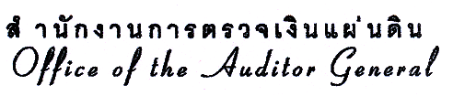
Based on the reviews, nothing has come to attention that causes the Office of the Auditor General of Thailand to believe that the consolidated and the Company’s financial statements are not presented fairly, in all material respects, in accordance with generally accepted accounting principles.

- 2 -

The Office of the Auditor General of Thailand previously audited the consolidated and the Company’s financial statements for the year ended December 31, 2004 of PTT Public Company Limited and its subsidiaries and of PTT Public Company Limited in accordance with generally accepted auditing standards and expressed an unqualified opinion on those statements in report dated February 16, 2005. The consolidated and the Company’s balance sheets as at December 31, 2004, presented for comparative purposes, are part of the financial statements which the Office of the Auditor General of Thailand has audited and issued a report thereon as stated above. The Office of the Auditor General of Thailand has not performed any other auditing procedures subsequent to the date of that report.

(Signed) Satja Sasanavin
(Satja Sasanavin)
Deputy Auditor General
for Auditor General

(Signed) Suchitra Sommanus
(Suchitra Sommanus)
Director of Audit Office

May 6, 2005

