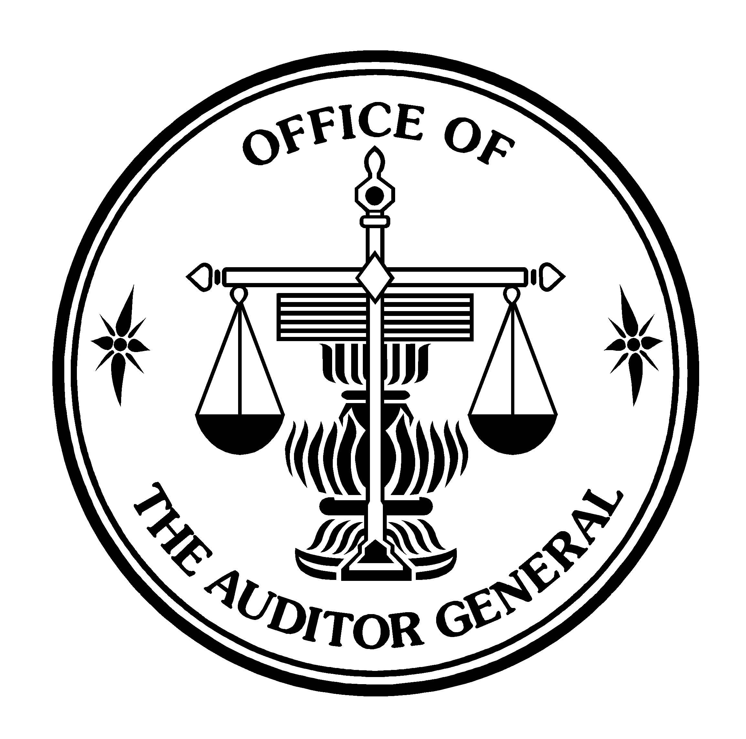

(TRANSLATION)

AUDITOR’S REVIEW REPORT

TO: THE SHAREHOLDERS OF PTT PUBLIC COMPANY LIMITED

The Office of the Auditor General of Thailand has reviewed the accompanying consolidated balance sheets of PTT Public Company Limited and its subsidiaries and the balance sheets of PTT Public Company Limited, respectively, as at March 31, 2010, and the related consolidated and the separate statements of income, changes in shareholders’ equity, and cash flows for the three-month periods ended March 31, 2010 and 2009. These financial statements are the responsibility of the Company’s management as to their correctness and completeness of the presentation. The responsibility of the Office of the Auditor General of Thailand is to issue a report on these financial statements based on the reviews.
The Office of the Auditor General of Thailand conducted the reviews in accordance with generally accepted auditing standards applicable to review engagements. Those standards require that the Office of the Auditor General of Thailand plan and perform the review to obtain reasonable assurance about whether the financial statements are free of material misstatement. A review is limited primarily to inquiries of the Company’s personnel and analytical procedures applied to financial data and thus provides less assurance than an audit in accordance with generally accepted auditing standards, accordingly, the Office of the Auditor General of Thailand does not express an audit opinion.
Based on the reviews, nothing has come to attention that causes the Office of the Auditor General of Thailand to believe that the consolidated and the separate financial statements are not presented fairly, in all material respects, in accordance with generally accepted accounting principles.

สำนักงานการตรวจเงินแผ่นดิน
Office of the Auditor General
2 -

The Office of the Auditor General of Thailand previously audited the consolidated and the separate financial statements of PTT Public Company Limited and its subsidiaries and of PTT Public Company Limited, respectively for the year ended December 31, 2009 in accordance with generally accepted auditing standards and expressed an unqualified opinion on those statements in the report dated February 19, 2010. The consolidated balance sheets of PTT Public Company Limited and its subsidiaries and the balance sheets of PTT Public Company Limited as at December 31, 2009, presented for comparative purposes, are a part of the financial statements which the Office of the Auditor General of Thailand has audited and issued a report thereon as stated above. The Office of the Auditor General of Thailand has not performed any other auditing procedures subsequent to the date of that report
.

(Signed) Poungchomnad Jariyajinda
(Poungchomnad Jariyajinda)
Inspector General

(Signed) Doungporn Muennuch
(Doungporn Muennuch )
Director of Audit Office

สำนักงานการตรวจเงินแผ่นดิน
Office of the Auditor General
May 13, 2010

