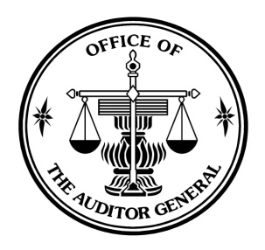

(TRANSLATION)

AUDITOR’S REPORT

TO: THE SHAREHOLDERS OF PTT PUBLIC COMPANY LIMITED

The Office of the Auditor General of Thailand has audited the accompanying consolidated balance sheets of PTT Public Company Limited and its subsidiaries and the balance sheets of PTT Public Company Limited as at December 31, 2010 and 2009, and the related consolidated and the separate statements of income, changes in shareholders’ equity, and cash flows for the years then ended. These financial statements are the responsibility of the Company’s management as to their correctness and completeness of the presentation. The responsibility of the Office of the Auditor General of Thailand is to express an opinion on these financial statements based on the audits and other auditors’ reports. The financial statements of subsidiaries abroad, subsidiaries arising from jointly invested between PTT Public Company Limited and subsidiaries or others, jointly controlled entities which are jointly invested between PTT Public Company Limited and others, and jointly invested between subsidiaries and others were audited by other auditors and included in the consolidated financial statements. The Office of the Auditor General of Thailand received other auditors’ reports and used them as a basis in auditing and expressing an opinion on the consolidated financial statements. As at December 31, 2010, assets and liabilities of the above subsidiaries and jointly controlled entities included in the consolidated financial statements constitute 34.64% and 33.80% and as at December 31, 2009 constitute 23.95% and 12.63%, respectively.

The Office of the Auditor General of Thailand conducted the audits in accordance with generally accepted auditing standards. Those standards require that the Office of the Auditor General of Thailand plan and perform the audit to obtain reasonable assurance about whether the financial statements are free of material misstatement. An audit includes examining, on a test basis, evidence supporting the amounts and disclosures in the financial statements. An audit also includes assessing the accounting principles used and significant estimates made by the management, as well as evaluating the overall financial statement presentation. The Office of the Auditor General of Thailand believes that the audits together with other auditors’ reports as above - mentioned provide a reasonable basis for the opinion.

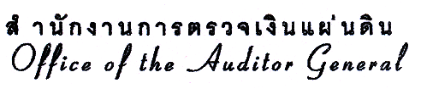

- 2 -

In the opinion of the Office of the Auditor General of Thailand based on the audits and the other auditors’ reports, the consolidated and the separate financial statements referred to above present fairly, in all material respects, the financial position of PTT Public Company Limited and its subsidiaries and of PTT Public Company Limited as at December 31, 2010 and 2009, and the results of operations, and the cash flows for the years then ended in accordance with generally accepted accounting principles.

(Signed) Poungchomnad Jariyajinda
(Poungchomnad Jariyajinda)
Inspector General

(Signed) Doungporn Muennuch
(Doungporn Muennuch)
Director of Audit Office

February 28, 2011

